Lockdown and Invacuation Procedure | 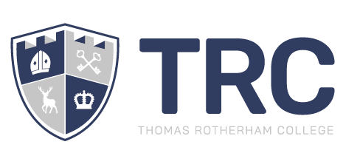


Implementation date | Summer 2025
Planned review cycle | Annually
Reviewed by | SLT
Last review | May 2025

TRC Ethos

At TRC, we understand the power of education to transform individual lives and communities.

In line with the overarching vision of Inspire Trust, we place our students at the heart of all that we do. We aim to foster their innate creativity, inquisitiveness and sense of wonder about the world and to show them how to realise their academic potential. We are restless in our commitment to expanding their horizons and promoting their understanding of the invaluable contributions they can make as both skilled and able citizens and as future leaders of a global society.

We recognise the importance of students leading rich and diverse lives. Working alongside our community, local and regional employers, other stakeholders and partner schools in the Trust, we will nurture all young people as fully-rounded individuals, confidently skilled and qualified to take their next steps, by providing opportunities for them to explore their spirit of engagement, adventure and ingenuity, both in the classroom and in the world beyond TRC.

We understand that students face challenges: that some require sustained additional support, while others need us to be there when their resilience falters. We believe no lesson is unteachable and no potential unreachable, and we will stand by all our students as a source of comfort and cajolement when they need us.

We are an engine of social change. As staff at TRC and as part of Inspire Trust, we recognise the privilege we enjoy in working with every member of our community. We aspire to achieve individual and collective excellence in all that we do and see it as our public duty to serve this community, delivering outstanding outcomes and extraordinary experiences.

STATEMENT OF INTENT

Purpose of this Policy
Thomas Rotherham College is committed to the health and safety and welfare of its staff, students, visitors and contractors.
The purpose of this policy is to provide all the college users with instructions in the event of an incident that requires a whole college lockdown - for example, a terrorist attack or other critical incident on or around the site; a dangerous, loose animal; the attempted access of the site or the presence on site of any person or persons, authorised or otherwise, who displays evident intent to harm or damage members of the college community – for example, by carrying a weapon.
These instructions will ensure that students, staff, visitors and contractors are safe in situations where there is an immediate threat or danger on the college grounds.

Scope
This policy and its procedures apply to all users of Thomas Rotherham College. This may be students, staff, visitors and contractors.

Policy review
This policy and its procedures will be reviewed yearly around the date of original implementation.

ROLES & RESPONSIBILITES
In the event of an incident which constitutes an immediate threat, it is the responsibility of all staff to ensure that the appropriate alarm is activated by informing Senior Leaders, Site or Reception staff. The activation alarm point is in the Site Services Team office. Site staff and Reception staff are instructed on how to deploy the activation.

Contact Reception: Dial ‘0’ from any phone in College

Contact Site Staff: Dial ‘730/ 731’ from any phone in College.

Where taking such action would represent a clear risk to the individual member of staff, that person should instead Run, Hide and Tell (this follows government guidance as set out in appendix A).
The Trust Board via the CEO and the Senior Leadership Team have the responsibility for this policy and procedures to be implemented. The management and implementation of this policy is delegated to the Principal, whose duty it is to secure its deployment and efficient operation across college.

ARRANGEMENTS

- The Lockdown Alarm Notification (CODE RED)

This will be a different sound to the evacuation alarm. The evacuation alarm is a continuous sound. It will not stop until the ‘all clear’ is given by the emergency services.
The Lockdown alarm is a sound with a 3 second gap in between sounds. The system will not stop it will carry on sounding but always with a 3 second gap in between sounds.
All Computers in College will show a CODE RED message across the screen to further alert staff and students that the Lockdown procedure has been activated or as a precautionary measure in the eventuality that the Lockdown alarm has been purposefully deactivated. In classrooms, the message will read “Full Lockdown activated - Please see emails for further instructions.” In social areas/in the LRC/Gym/S12, the message will read “Full Lockdown Activated – Run, Hide, Tell” in accordance with Government guidance.

Lockdown Procedures

Any member of staff who believes that the college is subject to immediate risk where a lockdown is necessary should inform Senior Leaders, Site or Reception staff immediately.

Reception and Site staff inform Senior Leaders, who will assess the threat before sanctioning the activation of the Lockdown alarm.

Where Reception and Site Staff are unable to contact Senior Leaders, they are empowered to take action and activate the Lockdown alarm independently.

What to do if the Lockdown Alarm sounds

All site users should be aware that there might be occasions where the alarm cannot be activated. When this is the case, and individuals or groups become aware of an immediate threat, the National Guidance states that during an attack you should Run, Hide or Tell (see appendix A).

In an Office or Classroom during lesson time, follow the CLOSE PROCEDURE

- Close all doors and windows within the room
- Lock up any door entrances to the room, barricade the door if possible, with desks, cupboards etc
- Out of sight (hide under desks if necessary, sit on the floor in a corner hidden from doors and windows
- Stay silent and avoid drawing attention to your presence. Put devices on silent
- Endure. Be aware you might be in lockdown for some time.
There are circumstances where the lockdown alarm may stop before the All Clear has been given (electrical fault, malintent from individual threatening the college). Best practice would be to wait until a senior leader comes to your door to give you all clear in person. In this instance, a safe word can be used should staff not be able to see the person. A Code Green message will also be sent via the Net Support system.
In social areas, the grounds or during a break time, follow the RUN, HIDE AND TELL guidance (see appendix A for more information)

- If close to a room, get inside and lock yourselves in and follow the CLOSE procedures.
- If you can’t get to a safety area national guidance advises to Run, Hide and Tell.
- Run – Run away from the danger
- Hide – If you find a hiding place hide from the threat, put your devices on silent
- Tell – Tell those around you of the danger so they can act appropriately.
Review your actions as the incident happens, you might be able to change your actions in order to keep safe.

What to do if there is a fire during the period of lockdown

While the lockdown alarm is in operation the fire evacuation alarm cannot be activated.
In the event of a fire taking place, staff and students must manage their well-being dynamically. Where hiding no longer becomes the safest option, the advice must be to run/ evacuate, removing oneself from the most immediate threat to life.

All Clear

The Lockdown Alarm may be disabled during an attack. For this reason, the period of lockdown does not end until the emergency services (who will be called during such incidents) deem it to be so. All site users should wait until the emergency services or members of staff instructed by them declare an all clear and ask all site users to leave the premises. A Code Green message will also be sent to all computers to inform staff that the threat is over.
Training

The college will aim to run emergency lockdown procedures training once a year. Staff and students will be informed prior of this as to minimise any concerns or anxieties people might have. Staff will be informed of these procedures in staff briefings and will, in turn, brief the students prior to and during the drill.

- The Invacuation Procedure

Invacuation Procedure

Any member of staff who believes that the college is subject to risk where invacuation is necessary should inform Senior Leaders immediately, who will assess the threat before sanctioning the activation of the Invacuation procedure.

Where Reception and Site Staff are unable to contact Senior Leaders, they are empowered to take action and activate the Net Support system independently.

There will be no alarm sounded for Invacuation. If the situation escalated from Invacuation to Lockdown, the above procedure would be applied.
All Computers in College will show a CODE AMBER message across the screen to alert staff and students that the Invacuation procedure has been activated. In classrooms, the message will read “Invacuation – please stay where you are until further instruction.” In social areas/in the LRC, the message will read “Invacuation – Please stay inside College until further instruction.”

Upon actioning, SLT will go to designated points around the building to ensure that staff and students are within the building.

When Invacuation has ended, staff and students will be informed through various methods of communication including email, text and a Code Green message via Net Support being sent.

- Code Blue alerts
If College is made aware of any credible threats within our locality/borough, a Code Blue message will be sent via Net Support to alert staff and students.

Code Blue messages are for awareness purposes only. No further action will be taken unless the situation escalates.
APPENDIX A

Stay Safe National Guidance (Run, Hide and Tell) gives some simple actions to consider at an incident and the information armed forces may need in the event of a firearms and weapons attack. Full guidance is contained on the NaCTSO website:

https://www.gov.uk/governement/publications/recognising-the-terrorist-threat.

RUN
- Escape if you can
- Consider the safest option
- Is there a safe route? RUN if not HIDE
- Insist others leave with you
- Leave belongings behind
HIDE
- If you can’t RUN, HIDE
- Find cover from gunfire
- If you see the attacker, they might be able to see you
- Be aware of your exits
- Try not to get trapped
- Be quiet, silence your phone
- Lock/barricade yourself in
TELL
- Call 999 – What do the police need to know?
- Location – Where are the suspects
- Direction – Where did you last see the suspects
- Descriptions – How many, features, clothing, weapons etc
- Stop other people entering the building if safe to do so
ARMED POLICE RESPONSE
- Follow officers’ instructions
- Remain calm
- Avoid sudden movements
- Keep your hands in view
OFFICERS MAY
- Point guns at you
- Treat you firmly
- Question you
- Be unable to distinguish you from the attacker
- Officers will evacuate you when is safe to do so
APPENDIX B

What to do during a Lockdown Drill

If you are in a classroom with students

- Explain calmly that this is a drill and allow students to become familiar with the sound of the Lockdown alarm.
- Discuss with students how you as a group might respond in the event that this was a live activation.
An exemplar might be as follows: “Ok everyone. Please stay quiet and calm. This is a Lockdown drill. The sound you can hear is the lockdown alarm and it is there to tell us that we need to take appropriate action to secure our safety. During a period of lockdown, the advice is to stay where we are and secure our area following the CLOSE protocols. In this room, we would close all the windows and, because we can’t lock the door, a few of us might barricade the door using the furniture in the room. What can you see that we might use?
Once the room is secured, we would need to hide out of sight. How might we do this? (Under desks, in an area of the room out of sight of windows, stay low etc.)
We’d also need to keep quiet. That would mean immediately putting our devices on silent and avoiding any urge to phone someone or to make any noises (including shouting for help) that might let someone who wishes us harm know where we are.
We would possibly be here for some time. What problems might that cause us? (water, toilet facilities, worry about friends and family members) What should we do to help address this? What should we not do? (see if alternative arrangements can be made (have fun with this!), explore how much water you have as a group, avoid using phones under any circumstances – even texting may set off an alert)”

If you are with students in an insecure environment but there is a secure environment nearby (e.g. in the LRC, study area)

- Gather the students together and explain calmly that this is a Lockdown drill. Allow students to become familiar with the sound of the Lockdown alarm.
- Discuss with students how you as a group might respond in the event that this was a live activation.
An exemplar might be as follows: “Ok everyone. Please stay quiet and calm. This is a Lockdown drill. The sound you can hear is the lockdown alarm and it is there to tell us that we need to take appropriate action to secure our safety. If we were in a classroom we would close windows and lock or barricade the doors before taking appropriate steps to take cover. We can’t do that here. In situations like this, the advice is to run, hide and tell. The first step is to see if we can find a nearby space where we might be able to find safety. In this case, there are spaces nearby. Can you think where they are? (upstairs in H&SC (for LRC), in nearby classrooms (for the study area) If those spaces are not available, the advice would be try and find an alternative place of safety, which might mean leaving the college site. You would need to avoid re-entering the building but, instead, take the nearest, safe exit route. Looking around you now, what do you think would be your best escape route from the site? If that was blocked or unsafe, what would your best alternative route be?
If you are with students but not in a secure environment (eg on Astroturf/ field, canteen)

- Gather the students together and explain calmly that this is a Lockdown drill. Allow students to become familiar with the sound of the Lockdown alarm.
- Discuss with students how you as a group might respond in the event that this was a live activation.
An exemplar might be as follows: “Ok everyone. Please stay quiet and calm. This is a Lockdown drill. The sound you can hear is the lockdown alarm and it is there to tell us that we need to take appropriate action to secure our safety. If we were in a classroom we would close windows and lock or barricade the doors before taking appropriate steps to take cover. We can’t do that here. In situations like this, the advice is to run, hide and tell. You wouldn’t be allowed to re-enter the building. Looking around you now, what do you think would be your best escape route from the site? If that was blocked or unsafe, what would your best alternative route be?

Where would be the best place to hide if you didn’t feel there was a safe escape route? When there, what additional steps might you take to stay safe? (phones – if they have them – on silent)

If you managed to reach a place of safety and felt secure enough to tell someone, who would you tell? (Call police) Who would it be wrong to inform? Why? (Parents or relatives may clog-up approach roads if they’re told before emergency services/ phoning friends in college might endanger them by alerting an intruder of their presence)”

If you are in an office or staffroom
- You should stay where you are and explain to anyone unfamiliar with the alarm that this is a Lockdown drill.
- You may allow into your office colleagues from nearby, non-secure areas.
- As soon as possible, you must take action to secure your office area, including locking doors, closing windows and taking precautionary action to minimise risks (staying out of site, away from windows, sitting on the floor, etc.)

APPENDIX C

Instructions for Reception and Site staff in the event of a credible threat.

- If the threat is immediate and apparent, the lockdown procedure should be initiated without hesitation.
Immediate and apparent – A threat is immediate and apparent if you personally witness the threat. You might also deem the threat as immediate by gauging the behaviours of others. If someone reports something, how do they seem? Can you gauge their levels of anxiety and evaluate the situation dynamically?

- In all other instances, you must make every effort to contact a member of the Senior Leadership Team.
Senior Leaders are contactable by telephone (see below) or walkie talkie (channel 3).
SLT contact numbers:

Principal
630 – Joel

Assistant Principals-
707 – Nicola
750 – Chris
697 – Mandy
651 – Emma

CEO
604 – David

Student Services Manager –
720 - Karen

- If you cannot raise a member of SLT this way, it is acceptable for you to temporarily leave your post and any task you are attending to and contacting SLT in person. If you do so, you should secure any immediate danger this might pose, e.g. locking computer to prevent GDPR breach if working in an office or, if working around the site, securing power tools and moving equipment to ensure that exits and corridors are not blocked.

- If you are unable to raise Senior Leaders through any means, you should activate the Lockdown Alarm. It is understood that a decision regarding the activation of the Lockdown Procedure is as difficult a decision as you might take. If you have followed this procedure, you should take any decision to activate, confident in the assurances that to do so is the correct response to the circumstances you face.

APPENDIX D

Responsibilities of Senior Leaders

Communication is critical. All leaders must have their walkie-talkie with them at all times. When in an office, your walkie-talkie should be in its charging port, switched on and set to channel 3.
If you asses that threat is immediate and apparent, the lockdown procedure should be initiated without hesitation.

If you are informed of a credible though not immediately apparent threat (for example, where it exists in the form of rumours or partial information, seems incongruous in context, etc.):

- Senior Leaders should attempt to contact as many fellow members of SLT as possible, including (where possible) the Principal or CEO. Effective decision making is often collective decision making.
- Senior Leaders should assess the situation dynamically. Additional information should be secured and triangulation sought – witnesses approached, CCTV accessed, the site walked and known or identified locations visited – with Senior Leaders maintaining open channels of communication at all times. Time will be of the essence in such instances and these actions must be undertaken promptly and efficiently.
- Once all immediately available information has been gathered and assessed, those Senior Leaders must make a decision. Where doubts remain due to conflicting or contrasting accounts/ evidence on the ground, etc. and, crucially, where there is no immediate evidence of danger, it is acceptable to take the time to consider further investigation.
- Where there is credible evidence, especially where that evidence can be triangulated, the Lockdown alarm should be activated. It is accepted that a decision regarding the activation of the Lockdown Procedure is as difficult a decision as a Senior Leader might take. Much depends on getting such a call right, with weighty consequences for getting that call wrong. That said, Senior Leaders should take any decision to activate, confident in the assurances that to do so – whatever the consequences – is the correct response to the circumstances they face.
- If you activate the lockdown alarm, you must contact the appropriate emergency service. This should be in the form of a 999 call, alerting the police and all emergency services to the situation.

APPENDIX E

How to activate the Lockdown Alarm

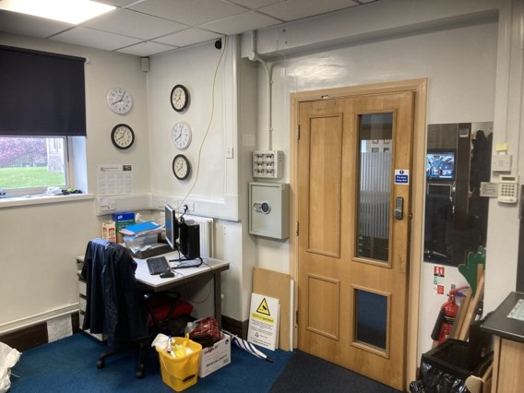
The activation switch is on a panel behind the door between the Site Office and Reception. The code to access Reception is C236XZ.

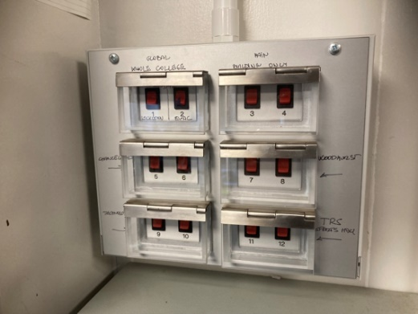
The panel contains activation switches for multiple alarms.

The activation switch is switch 1, at the extreme top left.

It is labelled ‘Whole College: Lockdown’
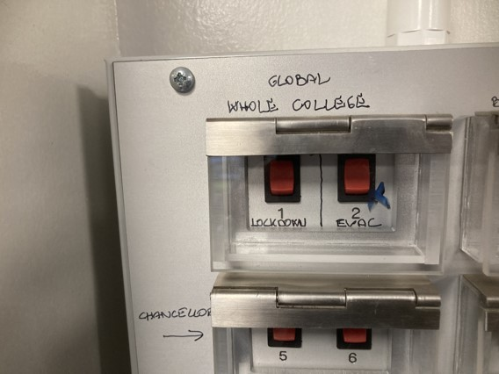
Once activated, the alarm will continue to sound until it is turned off.
You should not deactivate the alarm until you are told to do so by the emergency services.

Activation Checklist
- Activate alarm
- Call 999 and request Police support



In the event of the lockdown alarm being activated:

Close all doors and windows within the room.

Lock up any door entrances to the room, barricade the door if possible, with desks, cupboards, etc.

Out of sight (hide under desks if necessary, sit on the floor on a hidden corner from doors and windows).

Stay silent and avoid drawing attention to your presence. Put devices on silent.

Endure. Be aware you might be in lockdown for some time.

You will be told when the situation has been resolved. You must follow this guidance until the ‘all-clear’ has been given.

